Adding CSS to a Page

The best way to store CSS styles for a website is in external .css files, and linking them into the various web pages.

You can also store CSS per-page within <style type=”text/css”> tags in the <head>...</head> portion of the webpage.

You can inline CSS using the style attribute of a tag, but it is generally not good practice.

CSS format
In CSS, you style an element by identifying it by its element type (e.x., p, a, div, etc.), its class, or its id. Whichever type you use, you specify the identifier first, then enclose the styling rules within curly braces { }.
p { text-indent: 30px; } | Styling an Element
.story { text-indent: 30px; } | Styling an Element with the given Class
#chapter-1 { font-style: italic; } | Styling an Element with the given ID

Setting up rules for elements
There are various ways to specify rules for one or many elements, with the option of being more or less specific as needed.
CSS is based on specificity to choose what rule an element obtains, as it can get multiple styles from multiple rules, and rules can be overridden. The more specific your identifier is, the more likely its styles are to get priority.

For example, we could have a broad class:
.center { }

But, we can't center text and center divs in the same manner! So what would you put as the styles for the .center class?

p.center { text-align: center; } | Any paragraph tags with the class “center” use the text-align style to center the text.
div.center { margin: 0 auto; } | Any div tags with the class “center” use the margin style to center the container.

So, you can reuse the same class name but give specific styles based on the element type it belongs to.

You can do the same with an ID...
p#chapter-1 { text-align: center; }

Here, this style only applies to a paragraph with the ID “chapter-1”.

You can give multiple elements the same style by separating them with a comma:
h1, h2 { font-weight: bold; } | h1 and h2 tags will be bold now
a,  a:active,  a:visited { color: #ff0000; } | A standard link, a link with the psuedoclass active, and a link with the pseudoclass visited all will be the same color.

One element can also contain multiple classes:
<div class=”column col-1”></div>
<div class=”column col-2”></div>

There, this div will obtain styling from both the column class and the col-1 class. If they have colliding styles, it's hard to tell what will win out, but it might get separate styles from each...
.column { float: left; } /* All columns will float to the left */

/* Each specific column has its own styles, too */
.col-1 { width: 25%; }
.col-2 { width: 10%; }

You might want to style the same sort of element or same class in different areas of the page. For example, a news container might style the h2 tag differently from the photo-gallery container.
Here is where specificity comes in handy. You can style h2 tags in separate ways, based on who its parents are.

nav h2 { font-size: 30px; }
.news h2 { text-align: center; font-size: 13px; }
.photo-gallery h2 { color: #aaaaaa; font-style: italic; }

This can be as nested as it needs to be:

header { background: #aaaaaa; }
header nav { clear: both; }
header nav ul li { float: left; }

.main-content { background: #ffffff; }
.main-content ul li { list-style-type: none; }

Remember that you can use elements, classes, and IDs!

Layout nuances
Having your page flow in more than just a vertical format can be tricky until you're familiar with the tricks.

Layouts with Floats
You can stack containers next to each other, or on either side of a parent container, with float. Float can also be used to have an image only take up a portion of a region and allow inline (text) items to flow next to it.
img { float: left; }  Note that for this application, you do not need to have a clearfix. The non-floating elements have had their position altered, and this is desired here. | 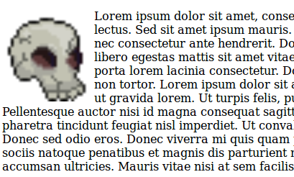

You can make elements float left or right, and they will stack against each other against either side of their parent container.
.container { border: solid 1px #000000; }

.div1 { width: 100px; height: 100px; background: red; float: left; }
.div2 { width: 100px; height: 200px; background: green; float: right; }
.div3 { width: 200px; height: 100px; background: blue; float: left; }

.clear { clear: both; }
<div class="container">
<div class="div1"></div>
<div class="div2"></div>
<div class="div3"></div>
<div class="clear"></div>
</div>
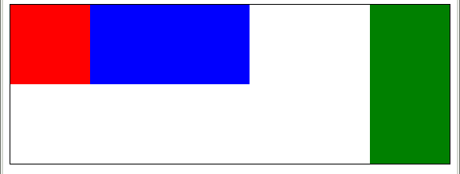

However, a clearfix is required if you are doing this. There are two ways you can fix the float error.
How do you know when you have a float problem on your hands? Look out for parent containers not showing up anymore – generally, their height has been reduced to 0px and therefore you cannot see it. Also look for elements after the floating items having their positions changed, or your page just looking twisted in general.

Layouts with Relative/Absolute Positions

Fixed Layout

Styles to know
You should know how to use these styles:

